MICROTEACH UNIT PLAN:
Pottery

Lesson 1: Clay Tile
Lesson 2: Slab Pot
Lesson 3: Coil and Pinch Pot

Ed 3601
Curriculum and Instruction
Gayle Nanninga and Meghan Verkerk
March 1, 2012

Art Pottery: Stage 1 – Desired Results
Established Goals | TRANSFER GOAL
Students will:  -review the elements of art  - respond to historical and modern images of pottery  - observe and sketch natural objects  - role out clay to create their own tile  - carve into clay tile to create an image  - role out even slabs to create a slab pot  - role coils to create coil pots  - work with clay to create pinch pots  - create final project of an organic abstract sculpture  - critique themselves and their classmates artwork | Students will be able to experience pottery through observing and manipulating clay to create organic and functional forms.
 | MEANING
 | Enduring Understandings:  Students will understand that…  U1 – The elements of art especially shape and space can be used to achieve positive and negative space in pottery.  U2 – The surface of clay can be modified and altered to create unique textures.  U3 – with creativity and by exploring various techniques in clay students will achieve a personalized interpretation of their artwork.  U4 – through exploration and playing with the clay can lead to unique forms, spaces, and shapes. |  | Essential Questions:  Students will keep considering…  Q1 – What are positive and negative space in sculpture?  Q2 – What is texture?  Q3 – How can pottery go beyond the functional/traditional and be created into a sculptural artwork?  Q4 – What are the ways that they can explore clay in an organic way?
 | ACQUISITION OF KNOWLEDGE & SKILLS
 | Students will know…  - The difference between slab, pinch, and coil pots  - How to change a traditional pot into an organic abstract pot.  - The pottery vocabulary:  - Firing  - Kiln  - Slip  - Scoring/Scratching  - Wedging  - Leather-Hard  - Relief |  | Students will be skilled at…  - Hand building techniques:  - using a rolling pin to make even slabs  of clay  - hand rolling clay into coils  - pinching techniques  - using scoring and slip techniques  to join pieces of clay together  - how to care for clay(drying and  preparing clay)  - how to critic pottery in a meaningful  and purposeful way  - creative texture in clay through scoring, scratching, carving, and smoothing clay with fingers and tools
-
Evaluative Criteria  Performance is judged in terms of |  | Assessment Evidence  Students will need to show their learning by:
Participation: class demos and project work  Completion: craftsmanship, proper use of techniques, clean appearance  Creativity: ability to move away from tradition pots, use unique organic forms  Critique: involvement class discussion and self reflection |  | Transfer Task: The students will show their learning by sketching, class discussions, practicing and working with pottery techniques, completing three final works of pottery, and critiques.

Unite Rationale:
At grade 9, this will be their first encounter with technical skills in pottery. At this age, they are able to comprehend the skills and techniques needed to create a successful pottery piece. As well, they realize that pottery is not all functional but can be sculptural. Students will gain a better appreciation for the elements of art through creating three-dimensional art.

Pottery is motivational for grade nine’s because it is a very interactive material, which allows students to play and be creative. Also, clay motivates students because of its three-dimensional forms. Therefore, allowing students the ability to see the whole sculptural form easily. Clay may be difficult with some students to achieve the technical skill as well as getting involved in the material. As a teacher, I will need to encourage all students that it is ok to get dirty and interact with the material at any level. As well, students will need clear perimeters when working with clay so they can succeed in their final projects. Working with clay is especially effective for the kinaesthetic learner because creating pottery is very interactive and is a hands-on activity. Also, pottery is universal to all ethnicities because every one is exposed to some form of dishes in their home. Pottery is cross-cultural because historically many cultures used pottery.

In our lessons, we contained various images, such as Rick Rudd, to suit the visual learners and inspire the grade nine students about pottery. The teaching strategies are manly hands on work, demonstrations, and discussions. This allows the students to build on their pottery skills and have the freedom of creativity. Each lesson includes perimeters that promote the students to problem-solve and experiment by adding appendages, holes, and creating an abstract object. Clay techniques and creativity must work together to make a completed project, challenging all the grade nine students.

Unit Summary:
The intention of the unit is for students to experience pottery through observing and manipulating clay to create organic and functional forms. The outcome of the unit is for students to understand that pottery has multiply purposes and can transcend from functional to sculptural artwork. Students will understand this transformation by using pottery techniques to create non-traditional organic pieces of sculpture. In this unit, organic forms and natural objects are a large inspiration for the students. This will be achieved through a nature walk and by allowing students time to reflect and draw in their sketchbooks. Throughout the unit, students will look at contemporary pottery images and demonstrations at the beginning of each lesson. As well, the demonstrations and working with the clay will allow the students to explore their creativity and expand their skills. The students will reflect on their work by one-on-one time with the teacher, group discussions, and critiques. This unit is sequenced to build on pottery techniques from a flat slab tile to three-dimensional containers. Then building on skills with pinch and coil pot techniques where the perimeters become more focused.

Lesson Summaries:

Lesson 1
The intention of this lesson is to introduce to students that clay can be manipulated into a tile. Students will do a nature walk outside to collect materials for inspiration. Then students will do a gallery walk of the natural objects and select three different natural objects. They will record/investigate their three natural objects in their sketchbook and write about their reflections on the natural objects, relating to personal interpretation and experience. After they have recorded their reflections, they will sketch each object in three different perspectives to decide which image would be most interesting to carve into the clay tile. Students will learn the technical skill on how to create a tile. Then they will explore different mark making tools that would best depict their chosen image. The technical skill on creating a slab will also be used in lesson 2 and 3.

Lesson 2
The intention of this lesson is to introduce to students that there are multiple purposes to pottery. Students will learn the technical skill on how to create a slab pot for functional and sculpture purposes. Also, students will explore how to drape a slab of potter over an object. The perimeters for the lesson is to create an abstract container that has one appendage, one hole, and includes texture.

Lesson 3
The intention of this lesson is to introduce students to the techniques and procedure of creating a coil and pinch pot. Students will take these techniques and apply them to their own sculpture. The final project is an organic abstract sculpture that needs to have three appendages, two holes, and a variation of textures.

Name: Meghan and Gayle
Grade/Subject: Art/ Grade 9
Unit: Pottery Lesson 1: Clay Tile
Date: March 1, 2012 Class Length: 45 minutes

GLO: Students will be able to experience pottery through observing and manipulating clay to create organic and functional forms.

SLO: Students will create pottery and sketches that are inspired from nature.

Learning Objectives: Students will:
- Create one tile by using pottery techniques of rolling, cutting, and carving clay
- Investigate three natural objects in their sketch book
- Create an image by carving into the clay tile based on their sketches
- Determine positive and negative space within their art piece
- Create balance between different textures

Resources Consulted:
http://www.nelldevitt.com/portfolio/view-square.php?id=4
http://www.nelldevitt.com
https://moodle.uleth.ca/201201/pluginfile.php/30605/mod_page/content/2/handling.pdf
Ceramics From Clay to Kiln by Harvey Weiss
Clay: Hand Building by Maurice Sapiro
Clay Work Form and Idea in Ceramic Design by Leon I. Nigrosh
Clay Works: 20 Americans by Museum of Contemporary Crafts of The American Craft
Environmental Ceramics by Stan Bitters
Low Fire Other Ways to Work in Clay by Leon I. Nigrosh
The Creative Use of Clay in First and Middle Schools by Michael Moulder

Materials:
- Sketchbook
- Pencil
- Canvas/board
- Knifes
- Wire (cutting clay)
- Modelling sticks
- Rolling pin
- Natural objects
- Bucket of water
- Rags
- Slip
- Two wood strips
- Clay
- Plastic bags (storing extra clay)
- Small plastic bags (for recording objects)
- Glue
- Tape
- Mark making tools: scrap wood, paper clips, comb, spoon, any thing you can find)

Teaching Strategies:
Lecture, hands on experience of materials, demonstration, examples, and discussion

Procedure:

Introduction (5 min.)
Artists to look at: Andrea da Pisano, student example, and Nell Devitt

Andrea da Pisano, South doors, Baptistery of San Giovanni, Florence

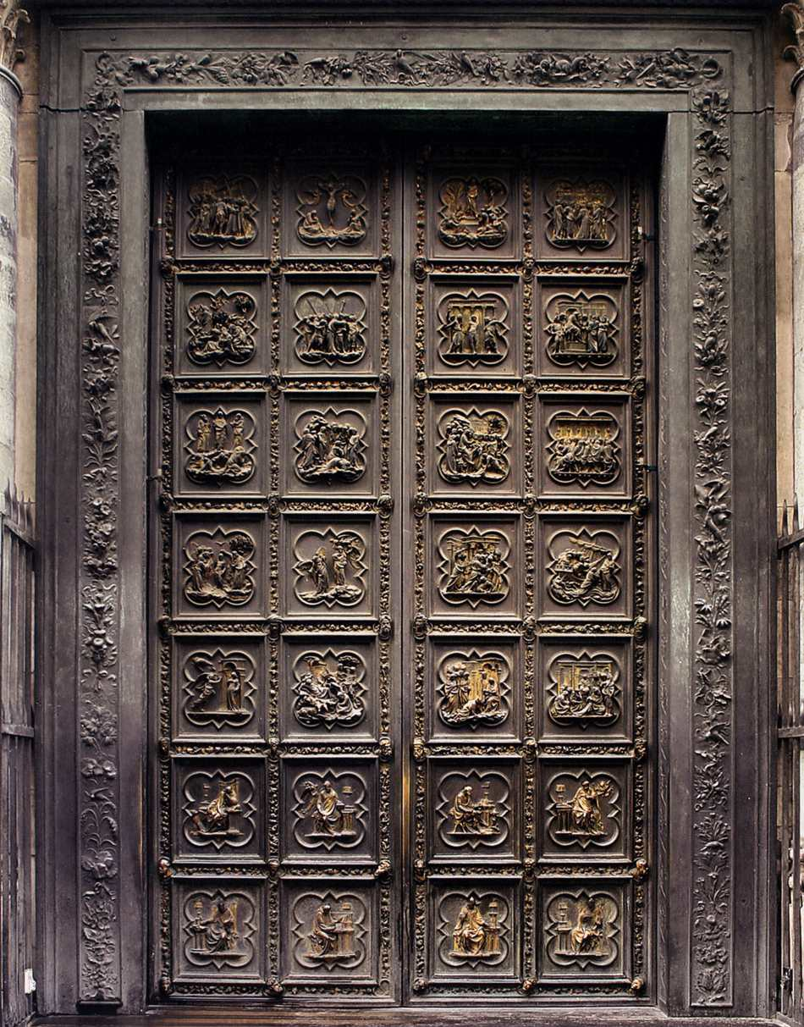
Describe the picture.
What materials are used?
How are the tiles organized? (repetition)
Are there textures?
What is the artist’s intent?
What kind of an effect does this image have on an audience?

“Clay Tile”
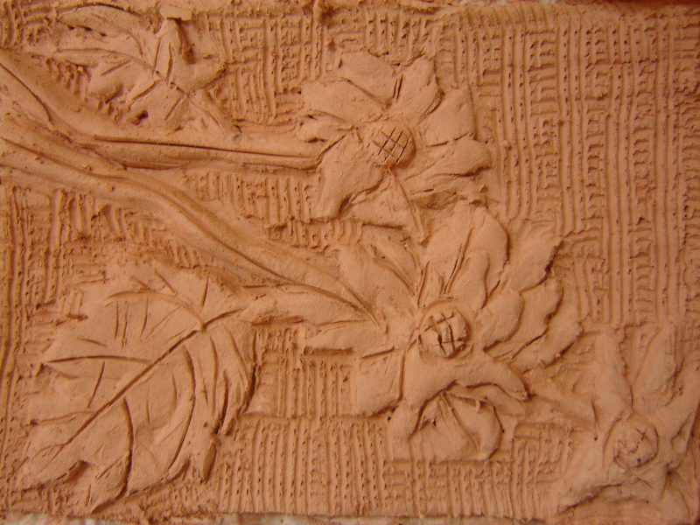
Describe the image.
What is the dominant element?
How would you describe the texture of the material?
Describe the positive and negative space?

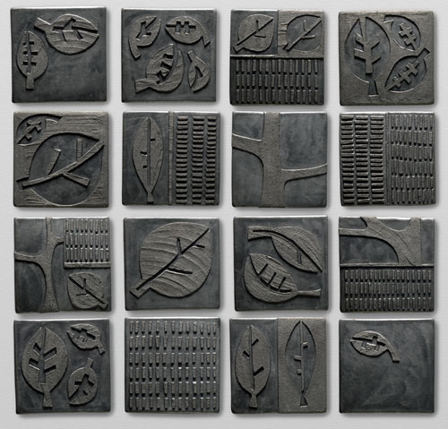
Describe the image.
How are the tiles composed together?
What textures do you see and how does the texture create line? Describe the line.
Is the meaning literal or ambiguous?

- Review the elements of art on the board
Body:
Activity 1: Observe Nature (10 min)
- Students will go on a nature outside to find various natural materials for their project
- Students will need to collect at least two kinds of leaves/needles, sticks/bark, and rocks
- Students will do a gallery walk, noticing all the natural objects
- Students will look, touch, and smell objects
- Students will organize objects onto specified groups

Table A | Table B | Table C
Leaf and Needles  (varies kinds for each table) | Sticks and Bark | Rocks or shells
(Teacher should provide other materials for the students)

- Students will choose 3 objects for their sketchbook
- Students must pick one object from each table
- Provide students the opportunity to trade with a classmate

- Students will investigate their 3 objects in their sketchbook
- Students will write about their experience looking at materials
- Students will record their 3 chosen objects
- Glue, tap, or bag materials in sketchbook
- State texture, smell, and sound of materials
- Students will write why they chose their 3 objects
- Students will write a memory connection to the objects
- Students will sketch each object in three different perspectives for their clay tile, also considering:
- Which image will be carved into the tile?
- How the image will be carved?
- What kinds of mark making would be necessary to describe the texture of the object?
- Where should the image be placed with in the tile?
Activity 2: Exploring Clay (25 min)
- Demonstration on creating a clay tile
- Lay canvas over board (purpose of the canvas is to keep the clay from sticking to the board and allows for moving the clay to another spot). Place two wood strips on top of canvas, about 20 cm apart (purpose of the wood strips is to keep the rolling of clay even).
- Take a piece of clay about the size of a large apple.

- Wedge the clay thoroughly.
    - Wedging Instructions: all air bubbles must be removed from clay for firing (air bubbles cause clay to explode in the firing process)
    - Take your piece of clay and cut clay in half with thin wire. Then the two halves are either slammed vigorously together or slammed down hard on a table top. Slam for 20-30 times until clay has an even consistency and free from air bubbles/pockets
    - To check when wedging is complete, cut clay it in half with wire and look to see if any air bubbles/pockets appear in cut surface. If there are still air bubbles/pockets, keep wedging.
- Spread the wedged clay between the two strips of wood.
- Role clay with the rolling pin, doing a back and forth motion, until clay is completely flat and even.
- Remove wood strips. Cut clay with a knife into a 5 x 5 inch square.

- Students will create a tile using the techniques above (if there are not enough materials, set up stations).
- Students will carve an image from their chosen sketch.
- Students must pick at least two kinds of mark making tools to depict their image.
- Students should experiment with mark making tools on scraps of clay before moving onto tile.
- Students will need to consider:
- balancing texture
- balancing positive and negative space (composition)
- placement of image
- Tiles should dry slowly, drying time will depend on thickness of clay
- When all tiles have been fired, students would arrange all the tiles together to create a unified collage (this would be another lesson at a later date).
Closure: (5 min)
- Critique questions:
- How can clay be used?
- What made you choose your natural objects?
- Did your sketches help you create your tile? Why?
- Why do you think artists use sketchbooks?
- How did you balance texture?
- What compositional strategy did you use? Why?

Sponge Activity:
Students can create another tile but the image needs to depict at least two natural objects (Student must pick different natural objects than from first tile).

Assessment Methods:

- Learning Objective 1: Students will have used clay techniques to create a tile.
- Learning Objective 2: Students will have experienced natural objects.
- Learning Objective 3: Students will have creatively used mark making tools to depict an image.
- Learning Objective 4: Students will have used positive and negative space to create a balanced composition.
- Learning Objective 5: Students will have used different textures to create a balanced composition.

Name: Meghan and Gayle
Grade/Subject: Art/ Grade 9
Unit: Pottery Lesson 2: Slab Pot
Date: March 1, 2012 Class Length: 45 minutes

GLO: Students will be able to experience pottery through observing and manipulating clay to create organic and functional forms.

SLO: Students will create three-dimensional abstract pottery.

Learning Objectives: Students will:
- Create one abstract slab pot by draping clay over objects
- Determine positive and negative space in their pottery
- Create an appendage for the pot
- Form texture in their pot

Resources Consulted:
www.rickrudd.com
Clay Work Form and Idea in Ceramic Design by Leon I. Nigrosh
Environmental Ceramics by Stan Bitters
The Creative Use of Clay by M.B Moulder
Ceramics From Clay to Kiln by Harvey Weiss
Clay: Hand Building by Maurice Sapiro
Clay Works: 20 Americans by Museum of Contemporary Crafts of The American Craft Council????????
Low Fire Other Ways to Work in Clay by Leon I. Nigrosh

Materials:
- Sketchbook
- Pencil
- Canvas/board
- Knifes
- Wire (cutting clay)
- Modelling sticks
- spoon
- Rolling pin
- Natural objects
- Bucket of water
- Rags
- Slip
- Two wood strips
- Clay
- Plastic bags (storing extra clay)
- Draping objects: sea shells, paper, burlap, varies containers, wood, cup

Teaching Strategies:
Lecture, hands on experience of materials, demonstration, examples, and discussion

Procedure:

Introduction (5 min.)
Artists to look at: Rick Rudd
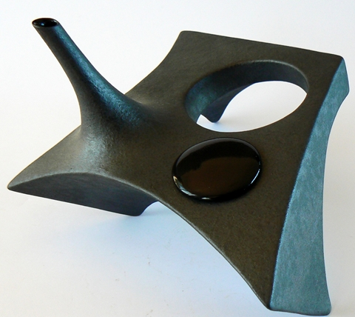
Describe the image?
Does it remind you of something else?
Do you think it is functional or sculptural?
Where is the positive and negative space?
What is the dominate art element?
What was the artist’s intent in creating this piece?

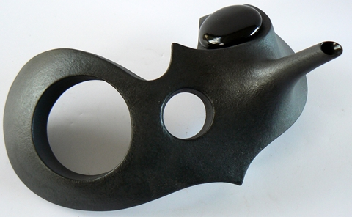
Describe the image
How do you think the sculpture is made?
Where is the positive and negative space?
Does the appendage change the image or what would happen if it were gone?
How is this image different from the first image?

Teaching Strategies:
Lecture, hands on experience of materials, demonstration, examples, and discussion

Body:
Activity#1: Slab Pot Building
- Demonstration on creating a clay slab pot (This demonstrate would be done at different intervals depending on where the students are at. The demonstration is to show techniques, not the final product.)
- Review and repeat steps 1 through 6 from creating a clay slab (lesson 1).
- Role out a slab for the base of the container. Make the clay slab larger than needed.
- Role out a second slab of clay for the walls (draping) of the container. The size of the clay slab will be determined by what it is draped onto. Trim edges.
- Using a drinking glass (or draping objects) to drape. Place drinking glass in the middle of base slab and score with knife on the base slab around the edge of the glass and add slip. Do the same with the bottom edge of the slab.
- Wrap the wall slab around the glass and press the wall firmly down onto the base without wrecking the form too much. (Note: watch for cracking to occur, keep squeezing and smoothing the outside of the curve as you bend it.)
- Cut off excess of wall slab and squeeze the edges together by scoring and adding slip. If necessary add some soft clay and smooth neatly, or else the bowl will have a bumpy, ragged seam.
- Remove the glass (glass has served its purpose). If glass does not come out easily, pour a little water around the edges and rotate glass slowly, gradually twisting the glass out. If class still does not come out, lift clay and glass up and poke a little hole through the bottom to let air in. After removing the glass, fill the hole with a little clay.
- With your knife, trim off the excess clay from the base slab. On the inside of the container, strengthen the seam where the wall meets the base by pressing in a thin roll of soft clay. Smooth the outside of the seam with a flat molding stick. (Note: your hand needs to fit into the chosen draping object.)
- Developing the rough shape of your bowl. Push out from the inside, slowly and carefully. If you want to narrow the shape, push in. Use a spoon or you fingers to push with and always support the other side of the wall as you do this. Keep turning the bowl as you work, using very light pressure. The changes must be made gradually. (Note: If walls become too misshapen, throw the clay back into the bag and start again.)
- Appendage: make the appendage separately. Score ends and use slip to attach to the container.
- Hole: Cut hole with knife and shape with molding sticks.
- Once you are satisfied with the shape of your abstract container, start adding mark making to create interesting texture.

- Students will create a slab container using the techniques above (if there are not enough materials, set up stations.)
- Students will need to transcend their container from a basic slab pot to an abstract sculpture
- Students will need to choose a draping object.
- Students must have at least one appendage and one hole in their bowl.
- Students must have texture or an image on their bowl.
- Students will need to consider:
- balancing the three-dimensional shape of the bowl, positive and negative space (composition)
- balancing the appendage and hole together
- balancing texture
- abstract qualities,
- process of creating bowl, order of appendage and hole (which should be done first?)
- Containers should dry slowly, draying time will depend on thickness of clay
- Place containers in kiln to be fired
Closure: (5 min)
- Critique questions:
- How can clay be manipulated?
- What sketchbook explorations did you find that helped with your final drawing?
- How did you balance texture?
- How did you balance the three-dimensional shape?
- What was your process in creating/applying the appendage and hole?
- By abstracting your pot through the draping process, would your pot be function or not?
- What was your intent for creating this work?
- Who is the audience for your container?

Sponge Activity:
Students can investigate another abstract container but add two appendages and three holes to the container.

Assessment Methods:

- Learning Objective 1: Students will have created one abstract pot.
- Learning Objective 2: Students will have used positive and negative space to create a balanced composition.
- Learning Objective 3: Students will have creatively applied an appendage and a hole.
- Learning Objective 2: Students will have used different textures to create a balanced pot.

Name: Meghan and Gayle
Grade/Subject: Art/ Grade 9
Unit: Pottery Lesson 3: Coil and Pinch Pot
Date: March 1, 2012 Class Length: 45 minutes

GLO: Students will be able to experience pottery through observing and manipulating clay to create organic and functional forms.

SLO: Students will learn and combine different pottery building techniques to create an artwork.

Learning Objectives: Students will:
- Apply pottery techniques to create a coil pot
- Apply pottery techniques to create a pinch pot
- determine positive and negative space in their pottery
- combine coil, pinch, and slab techniques to create an organic abstract sculpture

Resources Consulted:
http://elkmoundhighschool.wordpress.com/2011/12/07/native-american-coil-pot-lesson-plan/
http://aliceballard.com/pinch_pots.html
https://moodle.uleth.ca/201201/pluginfile.php/30605/mod_page/content/2/handling.pdf
Ceramics From Clay to Kiln by Harvey Weiss
Clay: Hand Building by Maurice Sapiro
Clay Work Form and Idea in Ceramic Design by Leon I. Nigrosh
Clay Works: 20 Americans by Museum of Contemporary Crafts of The American Craft
Environmental Ceramics by Stan Bitters
Low Fire Other Ways to Work in Clay by Leon I. Nigrosh
The Creative Use of Clay in First and Middle Schools by Michael Moulder

Materials:
- Clay
- Canvas/ board
- Knives
- Rags
- Bucket of water
- Slip
- Wire (cutting clay)
- Modeling sticks
- Plastic bags (storing extra clay)

Teaching Strategies:
Lecture, hands on experience of materials, demonstration, examples, and discussion

Procedure:
Introduction (5 min) Students will look on the smart board to see examples of coil pot and pinch pot.

Coil pot
Native American Coli Pot

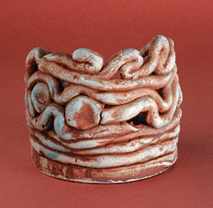
Describe what you see?
How would you describe the size of this piece?
How would you describe the shape of the material?
Are their positive and negative spaces?
Why do you think artist created this work?

Pinch Pot
Alice R. Ballard
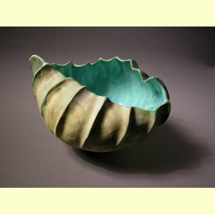
Describe what you see?
Is this functional pottery or artwork? Can they be both?
Does this work look organic or manufactured?
How does the light interact with the sculpture?
Does this artwork remind you of something?
What feelings do you have when you look at this pinch pot?

Body:
Activity 1: Coil pots (10 min)
Students will get a canvas board to work on with clay.
Students will watch a demonstration about the steps to make a coil pot
- Wedge clay ( may need to review steps from lesson 1 if students need a review)
- Take a piece of clay and gently roll the clay back and forth on the table to from a coil. Use both hand to have even pressure on the clay allowing the clay to become thinner and longer. It should start to look like a snake and be about the thickness of your finger.
- Once you have a long piece of clay 10 inches about you can start on joining pot together. Start by creating the base of the pot by coiling the clay around itself to form a flat spiral. The joining edges of the coil need to be scratched and then apply slip to the edges. Work with your finger to create a continuous coiled circle, remembering not to leave holes or cracks.
- Next build up the walls of the pot by first scratching and adding slip to the edge of the base. Then laying down a coil around the edge of the base and then add pressure to the clay so that the coil and base wedge together. Continue to build up the wall by pressing the clay coil around the edge of the pot. You may smooth edges with your finger.
- Let dry and then fire in kiln.
Students will create a small coil pot
Activity 2: Pinch Pot (10 min)
Students will watch a demonstration about the steps to make a pinch pot
- Wedge clay about the size of a small orange.( may need to review steps from lesson 1 if students need a review)
- Roll the clay into a nice ball shape.
- Pick up the clay in hand and start by sticking your thumb into the middle of the clay. Then start to create a larger opening by pushing or squishing the side of the clay with your fingers. Continue to work with the pot until you are satisfied with the end result.
- Let dry and then fire in kiln.
Students will create a small pinch pot

Activity 3: Final project (15 min)
Students will create an abstract sculptural artwork from imagination and play. The pottery piece objective is to create an organic feeling object inspired by the nature walk in lesson 1.
- Pottery instructions for final assignment.
- Students will creatively combine coil, pinch, and slab pots techniques.
- Sculpture piece cannot look like a traditional or manufactured pot.
- Sculpture piece needs to have at least three appendages.
- Sculpture piece needs to have two holes
- There needs to one area of clay that is smooth and one are that is textured on the final artwork.
- The sculpture needs to be able to contain something.
- Students will need to consider:
- pottery techniques
- balancing shapes to form a sculptural composition
- positive and negative space to add interest in their artwork

Closure: (5 min)
Students will have a class critique of their final sculpture artwork.
- Critique questions:
      - Describe what you see?
      - Describe the shapes?
      - Is their positive and negative space? Where?
      - What is the mood of this artwork?
      - What do you think this works means?
      - Does this artwork remind you anything?
      - What do you think could change to help to strengthen this artwork?

Sponge Activity:
Students can create another sculptural piece of artwork with clay.

Assessment Methods:

- Learning Objective 1: Students will have created a coil pot.
- Learning Objective 2: Students will have created a pinch pot.
- Learning Objective 3: Students will have added appendages and cut holes to create positive and negative space in their sculpture.
- Learning Objective 4: Students will have created an organic abstract sculpture.

