Matt Jones
(Digital Art)
Intro to Photoshop:
Juxtaposition
Janice Rahn
Art 3601 F1 (Spring 2014)

Photoshop Introduction: Grade 7
Established Goals | TRANSFER GOAL
Students will:  -Become introduced to the basic tools and principals of design software.  -Convey the elements and principals of design through a digital medium.  -Creatively explore the limitations of the program.  -Understand the creation and manipulation of layers.  -Use non-traditional materials for image creation.  -Create a digital juxtaposition using a digital medium  -Participate in a critique with fellow classmates | Students will be introduced to the process of digital image creation and manipulation. They will learn the basic tools and techniques that will be used in Photoshop to create their projects. Through exploration, inquiry and critical analysis, students will make connections between traditional techniques and the ones used in this new medium. They will also make connections between the elements and principals of design when working on their projects. Finally students will participate and evaluate each other during a class critique.
 | MEANING
 | Enduring Understandings:  Students will understand that…  U1 – Understanding the elements and principals of design are important even when working in a different medium.  U2 – Critiques are an important way to give and receive feedback from peers.  U3 – Each artist has their own unique style that they portray.  U4 – Certain elements of an image need to be considered when attempting to render a realistic piece. Example: Shadows |  | Essential Questions:  Students will keep considering…  Q 1 – How does this medium limit or enable me to create and edit my work?  Q2 – How does experimentation and play lead to new discoveries of a new medium?  Q3 – How do other students interpret an assignment differently than I do?  Q4 – How are the steps and skills required to make a composition similar to the process of creating a traditional piece of art?
 | ACQUISITION OF KNOWLEDGE & SKILLS
 | Students will know…  - How use the brush, eraser, marquee and movement tools in Photoshop.  - How to create, delete, and re-order layers in Photoshop.  - How to move elements of their composition around the canvas.  - How to use the elements and principals of design to create an effective composition.  - How to conduct an informational and helpful critique with peers. |  | Students will be skilled at…  - Use of the basic mark making tools in Photoshop.  - Basic layer manipulation techniques (movement, marquee, etc.)  - Import and/or creation of layers for use in a composition.  - Creating convincing images out of multiple elements.
STAGE 2 – Evidence
Evaluative Criteria  Performance is judged in terms of - Critique |  | Assessment Evidence  Students will showcase their mastery of tools and understanding of principals of design by using Photoshop to create an image that falls within the guidelines provided by the teacher. Students will also justify their piece during a class critique.
Participation  Completion of Assignments Rubric Criteria  Exploration (formative)  Mastery of the tools |  | Transfer Task:  Students will be introduced to Photoshop and will be exposed to a number in artistic examples that were created using the program. The students will learn the basic tools and techniques of the program by participating in teacher directed creative projects using the program. They will make the connection between the element and principals of design and the tools that they will be using in Photoshop; example: The connection between the brush tool, line and shape. The students will use the tools and techniques that they have learned to create a juxtaposition image based on an assignment criteria. Finally the students will participate in a class critique where they will both answer questions about their own work and ask questions about classmates work.

Grade 7 Digital Media
Unit Summary
This is an interdisciplinary unit that combines both art and technology while maintaining the principals and elements of art and design. Students will be exploring the use of digital design programs (Photoshop) while making connections between the tools they are using and the traditional approaches to image making. The students will begin the sequence by learning the basic mark making tools in the program. They will progressively learn more complex tools and techniques until they are skilled enough to tackle a large project. They will use the knowledge and skill that they have acquired to create a juxtaposition image that they will present to their peers in a class critique.
Rationale
Students are growing up in an age where technology is a prevailing element in their lives. Many students know how to use basic communication technology and even some image creation tools. It is important to teach students how to learn new programs through inquiry and exploration as well as showing them what the programs that they have available to them are capable of. I expect that the skill level with this program will be relatively low so much of the learning in this unit will be basic and exploration driven. There will be a small amount of technical instruction given by the teacher but once that is complete the students will be encourage to spend some time exploring the tools and techniques that they have learned in order to master them. The students will also be taught about the connection between the image making on the computer and the traditional principals and elements of design.
Lesson Summaries
Lesson 1: Line, Shape, Eraser and Layers
Students will be introduced to Photoshop during this class. They will be shown how to create a new document and will have the dimensions explained to them. They will also be shown where to save their work and how changing the dimensions can and will affect the size of their files. The students will then open up a new project and save it in their file. Following that, students will be introduced to the brush tool, followed by the eraser tool, then the introduction to layers. The teacher will give time between each new topic for the students to explore. They will then participate in an interactive activity with the teacher that uses all of the tools that they learned this class.
Activity: Layer Burger

Lesson 2: Move, Marquee, Cut and Paste
Students will be introduced to the techniques used to move whole layers around a Photoshop Canvas. They will be shown that layers can be moved around in the layer menu to change how the layers stack as well. The students will then be shown the marquee tool and how it can be used to move specific selections of a layer around on the canvas. Students will then be introduced to the use of copy and paste, isolating the wanted section of an image and copying it to a new layer. Finally students will be shown a number of different ways in which a new image can be added to their composition. Students will work with the teacher through these mini lessons and will be given example items to practice on. The activity at the end of the lesson will be students driven. They will use the techniques that they used to complete the objective. The teachers will formatively assess and assist the students that are struggling. Peer assistance is encouraged.
Activity: Exquisite Face

Lesson 3: Making a Juxtaposition
Students will be introduced to the concept of a juxtaposition and they will be shown a number of examples; both of professional traditional artists and of digital artists. They will use the internet and/or their cameras to retrieve images for this project. Using the tools and techniques that the students have learned during the past two classes they will create a juxtaposition image on Photoshop. The teacher will provide a rubric and a set of criteria that the students will have as a guide. After a set amount of time they will be formatively assessed by the teacher as he/she walks around the classroom. The students will also show their work in progress to their fellow classmates and they will exchange constructive comments (two positive for each negative) before returning to their work. Once the project is complete the teacher will hold a class presentation of the students’ work on the smart board. The students will be given time to talk about their work before being asked questions by their peers.
Activity: Juxtaposition
GLOs & SLOs
Outcomes for this unit come from multiple courses located in the high school CTS: MDC program of studies.
1. (Visual Composition) Identify and discuss the elements and principles of design
1.1 define the elements of design
1.2 identify the elements of design using examples
5. (Graphic Tools) Present a selection of work completed in this course to an audience
5.1 Discuss work regarding:
5.1.1 How the elements and principles of design help facilitate good composition
5.1.2 The technical and creative aspects of the work; e.g., quality, uniqueness
5.1.3 Areas of concern/difficulty (if applicable)
5.1.4 Meeting school and community standards; e.g., appropriate language
5.1.5 The use of tools and equipment
6. (Visual Composition) Participate in a critique or an assessment of compositions created by others; e.g., classmates, professionals
6.1 identify elements and principles used in the images
6.2 comment on the impact of the elements and principles in the construction of the message
9. (Visual Composition) Make personal connections to the cluster content and processes to inform possible pathway choices
9.1 Complete/update a personal inventory; e.g., interests, values, beliefs, resources, prior learning and experiences
9.2 Create a connection between a personal inventory and occupational choices

Lesson Plans
Lesson 1: Line, Shape, Eraser and Layers
GLOs & SLOs
1, 5, 9,
Objectives:
Students Will:
- Be introduced to images creation and manipulation programs (Photoshop).
- Learn basic mark making techniques used in these programs.
- Make the connection between traditional media and digital media.
- Understand how the elements and principles of design are applicable to digital art as well.
- Create a layer based composition.

Materials:
- Computers
- Photoshop
- Smart board
- Examples of line art (both traditional and digital)

Introduction:
Students will be asked to log into their computers and start up Photoshop. They will also be asked if they know how to save in their personal files on the computers. If not that is the first thing that the teacher will explain to them. Students will be shown a number of examples of line art created both by traditional artists and by digital artists. They will discuss the quality of line and the how the lines work together to create shape, defining positive and negative space.
Questions:
Describe what images you see?
What images appear more 2D and which ones more 3D?
Why do you think some images appear more flat than others?
How does changing line weight and quality create the illusion of depth?
At what point does space begin to become positive and negative, defining space, while a line is being made?
Why do you think our mind finds shapes in a 2d space like a canvas?
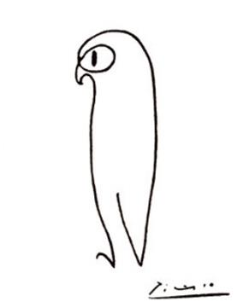
Owl: Pablo Picasso

The Cat: Pablo Picasso

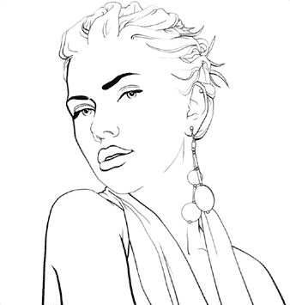

Scarlett Johansson: Melissa Evans

Body:
Students will look at these examples of line are and discuss how the line quality differs in each one. “Owl” has a single line that does not change in quality at all until you look at the eye. “The Cat” has a great deal of line variation in both weight and quality. Finally “Scarlett Johansson” is a digital line work that has very clean line quality and a great deal of line variation. The teacher will discuss these examples with the class and they will be asked formative questions about line while experimenting with line on Photoshop.
Students will begin their work by creating a new canvas in Photoshop. The teacher will discuss the different sizes of the canvases and how the size effects the amount of space the file takes up on the computer. The teacher will also look at the different size measurements that the students can choose (pixels, inches, etc.). When the students have created a canvas and saved it into their file they will be introduced to the brush tool. This is the simplest mark making tool in Photoshop. They will be asked to write their name on the canvas and experiment with brush size and quality to see the different marks they can make. Students will then be introduced to the eraser tool. They will erase parts of their name and re-draw them. It is good to note that on the bottom layer the eraser tool actually acts as a second brush, painting the colour that is set as secondary. Finally students will be introduced to layers. I would explain it like stacked panes of glass; being able to see through each one unless something is in the way and positioned above another element. Students will be allowed time to experiments with the creation and manipulation of layers at this time.
Activity: Burgers
Students will work with the teacher on a step by step creation of a burger (shown top down). They will create the first bun on the bottom layer, then each following condiment, meat, or vegetable on additional layers moving up. Students will be shown and asked to label each layer when creating it to help organize their image. They will conclude their burger by copying and pasting the original bun layer from the bottom onto the top. The students will be formatively assessed and assisted by the teacher during this activity.
Closure:
In the conclusion of the class students will be encouraged to experiment and decorate their burger with the extra time before the end of the period. During this time they will be shown how to hide and move individual layers as a “sneak peek” into what they will be dealing with during the following class. Finally the students will be asked to save their final burgers in their personal file before the end of the class. The students will be asked to fill out a small exit slip with any questions that they may still have and/or comments about the class.
Questions:
How do you think you could use the layers to edit an image without risking the entire piece?
What do you think layers are most comparable to in traditional art?

Lesson 2: Move, Marquee, Cut and Paste
GLOs & SLOs
1, 5, 9,
Objectives:
Students Will:
- Learn how to move individual layers on the canvas.
- Change the order of layers in the layer stack.
- Become introduced to the marquee tool and how it can be used to create selections.
- Copy and paste selections from one layer to another.
- Import images into their composition for editing.

Materials:
- Computers
- Photoshop
- Smart board
- Examples of layer art

Introduction:
Students will be asked to log into their computers again and open up Photoshop. They will be working with layers again in today’s lesson. The teacher will show the students a couple of examples of how layers work digitally and how they have worked in the past. The first image is from Disney Studios and it demonstrates how they would create the moving backgrounds in their old movies. Each element would be placed on a pane of glass and the artists would film through the glass and capture the image of all the stacked layers. These layers could be individually moved and altered to give the illusion of a completely animated background. The second example is of a pin-up image that has been created using stacked layers. The students will be asked how the layers shown in the image stack to create the final picture.
Questions:
What do you think the men in this picture are doing?
How do you suppose the concept of these to images are related?
How could these techniques be used to create the illusion of depth?
Explain how you think layers would give you artistic freedom when altering your image?
What other uses do you think images could be used for? Film or image based?

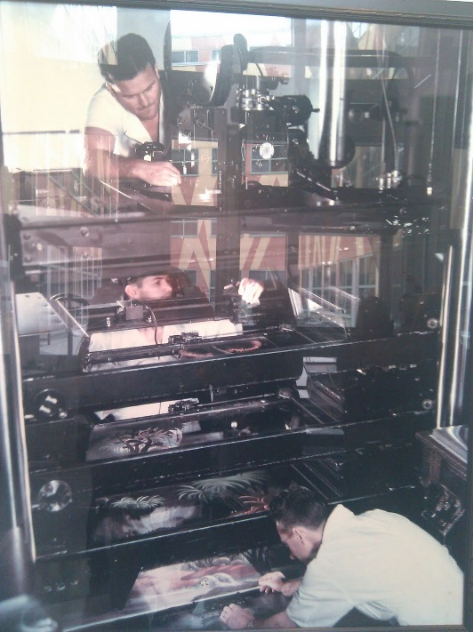
Disney background artist filming through background layers

Layer structure example: Alex Gumerov

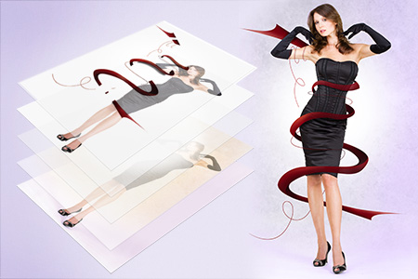
Body:
Students will be asked to start a new image and name it “Alien”. The students will then be asked to draw a face on a single layer, including two eyes, a nose, and a mouth. The students will then be shown how they can use the marquee tool to select specific parts of an image and move them around the canvas. They will be asked to move the eyes of their face lower on the canvas. The problem with doing this, as the students will soon discover, is that they will interrupt the other parts of the image on the layer.
The students will they be asked to create an exact copy of the nose and place it somewhere else on the face of their character. They will be shown by the teacher how to select part of an image using the marquee tool, copy or cut it, and paste it on its own layer. The students will recognize that they can now freely move this part of the image around without disturbing the other parts of the image. The teacher will give the students a few minutes to modify their face that they have drawn into an alien by copy, pasting, and moving layers around. Once this is complete the teacher will ask the students to save their files in their folder and create a new canvas.
Activity: Exquisite Face
Students will be asked to create a new layer on their project and label it “face”. They will use pictures from their camera/phone or from the internet of a human face. They will then get up and move one computer over, create a new layer, name it a section of the face (eye, nose, mouth, ears, etc.). The students will then find another image of a face and will select a portion of it and add it to the composition. They will be shown by the teacher as an example how to select (using the marquee tool), copy the selection out, and paste it into a new layer. They will then be shown how to use an eraser to blend the edges of the selection to make it seamlessly blend into the old image. The students will continue to move around the classroom like this until they have all had a chance to complete a face. Once the faces are complete they will be asked to return to their desks and save the images in their files.
Closure:
The students will then have a small critique of the works of art that they produced. They will get into groups with the students on either side of themselves and talk about what they do and do not like about the project. Students will be allowed to modify and play with the face images that they have created for the remainder of the class. The kids will be encouraged to write down on an exit slip what they would like to learn next, what they would like to know more about, and any other questions they may have.

Lesson 3: Making a Juxtaposition
GLOs & SLOs
1, 5, 6, 9,
Objectives:
Students Will:
- Understand what a juxtaposition is.
- Use layers and their Photoshop skills in the design of a project.
- Create a work juxtaposition work of art.
Materials:
- Computers
- Photoshop
- Smart board
- Examples of juxtaposition

Introduction:
Juxtaposition: the fact of two things being seen or placed close together with contrasting effect.
Students will be introduced to the concept of juxtaposition. They will have a brief discussion with the teacher as a class to assess their prior knowledge of the concept. They will then be given 5 minutes to use the computer to locate the best example of a juxtaposition piece of art. Once the time is up the students will be asked to show a couple of the examples to the class and talk about why they think that they are a juxtaposition. The students will then be shown a couple of images by the teacher and they will discuss the concept on contrasting images before moving on to the project.
Questions:
What do these images make you think of?
Do you find them confusing or do they make sense?
What is contradictory about the images?
What is a juxtaposition?
Can you explain what makes things contrast?
Explain why this image in a juxtaposition.

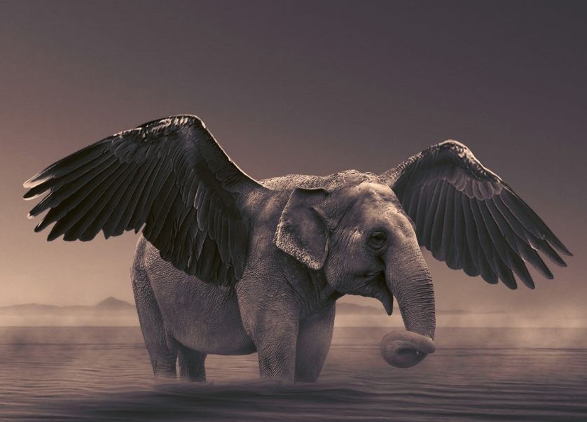
Elebird (elephant + bird)

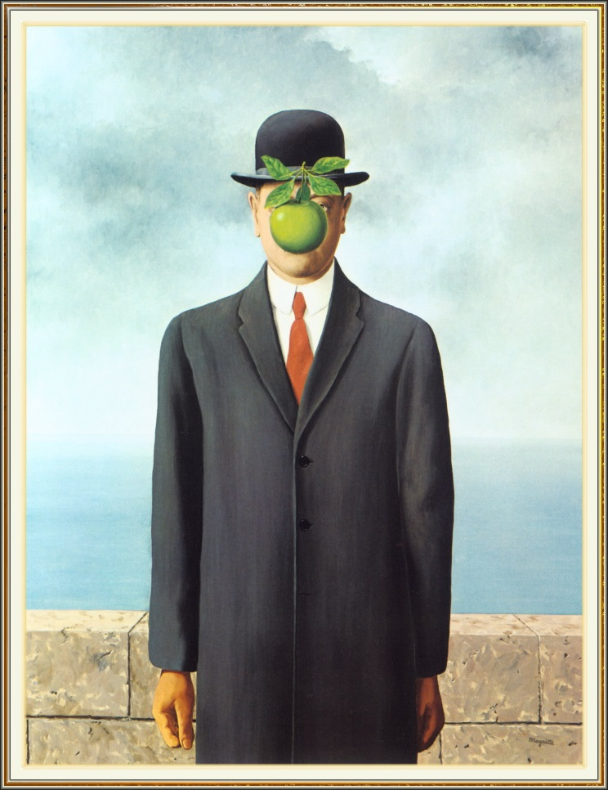
The Son of Man: Rene Magritte

Body:
Students will be given their assignment task. Then must complete the assignment within an allotted time determined by the teacher and they will be graded on a rubric. They will be allowed to see the rubric and also to see the criteria that they will be graded on. During the activity the students will be asked to stand up and move around the classroom as a group, looking at others’ works of art. They will be asked to provide a critique based question or comment to the creator of the work. The students will then return to their own work.
Assignment: Photoshop Juxtaposition
Create an artistic juxtaposition using Photoshop.
Performance Task:
Use at least 2 images that you capture yourself using a camera/phone or that you find on the internet to create an artistic juxtaposition. These images must be original images (un-altered) before importing them into Photoshop. Use the skills and techniques that you have learned over the past few classes to seamlessly combine these images into a completed piece. You will have breaks during the class to move about and talk with your classmates about their projects. These act as an informal, formative critique and should be used as a suggestion about what to work on more. Once you have completed your assignment please check with the teacher before moving on. Once you have completed your assignment you are free to explore and create more using the program.

Criteria:
Size- No bigger than 2000 pixels by 3000 pixels (landscape or portrait)
At least 2 original images.
Use of multiple layers.
Evidence of image altering. Do not use one complete image within another, use bits and pieces.
Believable blending of the images.
Check with Mr. Jones.
Save file in your personal folder.
Be able to defend your image as an artistic juxtaposition.

Closure:
Students will have a class critique once all of the assignments are complete. The teacher will display a number of the works on the smartboard or the class will move as a group again around to personal computers. Students will be asked to defend their work as a juxtaposition and explain what gave them the inspiration to make this piece. They will also be asked questions by the teacher about their work.
Critique Process
Students will be asked a number of questions by the teacher based on the four steps of critiquing artwork. The teacher can ask any number of questions from each section but must make sure to ask at least one from each.
Section 1: Describe
What is the theme of this artwork?
What is the dominant colour of the artwork?
What kinds of objects make up this artwork?
How many dimensions are in the artwork?
Section 2: Analysis
What does this artwork remind you of?
Describe the principles of art you see in this image.
Describe the elements of art you see in this image.
Describe the relationship between positive and negative space in the artwork.
Is the composition balanced?
Do you see a pattern in the artwork?

Section 3: Interpretation
What do you find symbolic in this artwork?
What do you think the meaning of this work is?
What do you think the artist is trying to say with this piece?
What does this image make you think of?
What emotions do you feel looking at this image?

Section 4: Judgment
What do you like about the artwork?
What do you think needs improvement?
What do you think about this artwork and why?
Would you hang this piece up in your home?
Do you feel like this artwork fit the theme appropriately?

Bibliography:
Books:
Lea, Derek. Creative Photoshop CS4 digital illustration and art techniques. Amsterdam: Focal Press/Elsevier, 2009. Print.
This book is a great resource for learning Photoshop. It has plenty of excellent project ideas and step by step instructions on how to complete these projects. It can also be a valuable resource for inspiring students to come up with their own projects.
Websites:
http://www.photoshopessentials.com/
This website is a great resource for getting lesson ideas and inspiring students to think about what is possible with image editing software. There are many tutorials on this website and they are very effective at giving step by step instructions.

http://www.photoshop.com/
This website is a great resource for everything related to the program. It has a learning section with instructional videos to teach new techniques about the program. It also has a spotlight section where you can read about professionals that use the software and become inspired by their work.

