The Lost Thing
By Shaun Tan
An Integrated Unit Plan
Art and English Language Arts 10

By Colleen Davies
ED 3700
C & I for Non-majors Art
Summer Session 2015

The Lost Thing by Shaun Tan
 | TRANSFER GOAL
Students will:  - Record visual information.  - Investigate visual relationships  - Express individual insights  - Practice articulating their understanding and choices | ELA 10 GLO’s Students will listen, speak, read, write, view and represent:  1. To explore thoughts, ideas feelings and experiences.  2. To comprehend literature and other texts in oral, print, visual and multimedia forms and respond personally, critically and creatively.  4. To create oral, print visual and multimedia texts, and enhance the clarity and artistry of communication.  Art 10 GLO’s  Drawings  Components 2 – Solve teacher directed problems of unity and emphasis in creating compositions.  Encounters – Compare the image content of certain periods
 | MEANING
 | Enduring Understandings:  U1 – Artists and authors have made strong statements against urbanization through their art and writing.  U2 – Art has had a positive impact on our environment through out time.  U3 – There are many people who go through life unnoticed. |  | Essential Questions:  Q 1 – What will my art say about urbanization?  Q2 – How can people be more inclusive?  Q3 – What is Utopia?
 | ACQUISITION OF KNOWLEDGE & SKILLS
 | Knowledge,  Will become familiar with the book, The Lost Thing by Shaun Tan.  Will become familiar with works of art that inspired Shaun Tan to write The Lost Thing.  Will be aware of the different elements of images, such as shape and texture and how these can suggest relationships.  Will gain understanding of the process of transferring text to film. |  | Skills,  Will practice drawing a character from different and unexpected perspectives.  Will respond in writing to connections between images and text in the book  Will explore connections between our world and the worlds portrayed in The Lost Thing.  Will learn how to manipulate materials in order to create a 3-D character.  Will draw and write a comic.
STAGE 2 – Evidence
Evaluative Criteria  Decision making, understandings technical competencies. |  | Assessment Evidence  Observations Discussion Product
The primary focus of these lessons rests on the student’s use of creative decision-making. |  | Decision-making and understandings will be assessed based on the student’s written and drawn responses to the art and literature studied.  Technical competencies will be assessed based on the students’ products, and through observation of their work process.
Unit Summary and Rationale
This unit will be taught in a grade 10 English Language Arts Class with the purpose of integrating art projects with the study of the book The Lost Thing by Shaun Tan. I think that students of this age will be able to relate to the style and ideas that are prevalent in the art of this book. Living in the digital age of today it is important for students to consider the connections between the natural and the urbanized worlds that we move between. In this unit students will write about and represent these connections by forming their own interpretations and positions on the images and texts of Tan’s art. Students will also have encounters with other artists such as John Brack, Hieronymous Bosch, Wayne White and Art Spiegelman. Some of these artists had significant influence upon aspects of the worlds and creatures that Tan created for his book The Lost Thing.
Students will be introduced to artists individually as they relate to each lesson. The progression of lessons will allow them to experiment with drawing, the creation of 3-dimensional art and a culminating collaborative project where they will create their own story, which will incorporate art and writing. Each lesson will include both writing and an art component. Students will participate in the critique of their own art as well as peers. They will also write responses and reflections to aspects of the worlds and creatures of The Lost Thing. Much of the focus will be upon how Shaun Tan combines the industrial and the organic. A class blog/website will be created where students will share photos of their work and be able to write critiques in the comments.

Conceptual Map
Cognitive domain
- Understanding of two and three dimensions
- Understanding the process of transferring images to film
- Understanding how the industrial and organic can be combined in interesting ways
- Recognising that contrast adds interest
- Understanding form, structure and medium
- Understanding varying and similar perspectives of different artists
- Understanding the process of critique and self assessment
Psychomotor
- Developing strategies to create realistic drawings
- Observing the difference between different qualities of paper
- Manipulation of materials to create 3 dimensional art
- Developing hand eye coordination
- Observing other artists techniques and styles
Affective
- Appreciating the effectiveness and artistry of print and non print texts
- Appreciating other classmates art
- Appreciating art history
- Gaining confidence and a sense of pride in one’s own art
- Exploring creativity
- Identifying self as part of popular culture
- Appreciating the complexity of the assignment and putting forth full effort
- Gaining confidence and appreciation for own art by critique and self assessment
- Identifying with real world environmental issues.
Lesson Summaries
Lesson 1 – An Introduction
In lesson one we will read the book, ‘The Lost Thing’ and watch the video of ‘The Lost Thing’. We will have a discussion about student’s thoughts on the meaning of the story, the style of art and how they are able to relate to these ideas. We will also talk about the differences between the book and the film. Students will make a simple collage with a combination of newspaper and bright coloured magazine pictures to show the contrast of industrial and organic life.
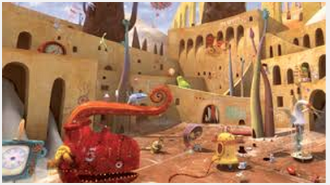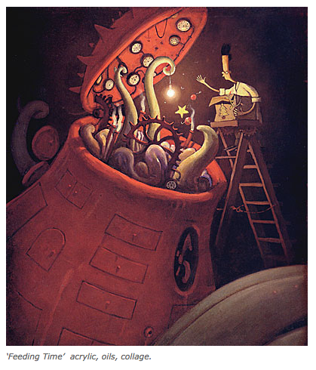
Lesson 2 – Creating a Creature
This lesson will involve a writing and a drawing component. Students will choose a creature from the book that interests them. We will have a brief discussion about how Shaun Tan has combined organic and inorganic elements to create his creatures. Have students think about the creature they would like to create and write about it before drawing it. Have images of interesting animals that do exist in our world and other objects that might be combined in some way to create new and interesting creatures. After students have written about their creatures they will draw several detailed pictures of them from different perspectives. Encounter with art by Hieronymous Bosch and John Brack.
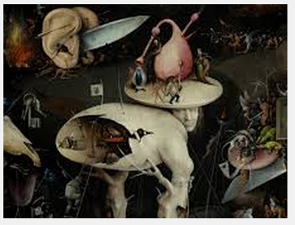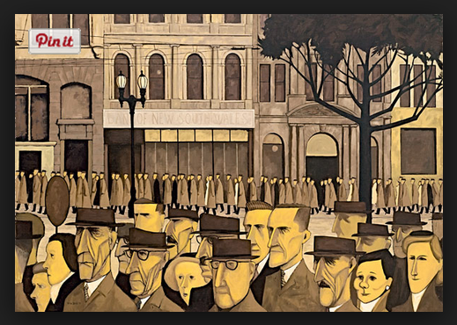
Lesson 3 – 3 Dimensional Creatures
This lesson will be a continuation of lesson two. Students will be asked to bring paper towel rolls, cereal boxes, cans, lids, yogurt containers etc. They make a 3D representation of the creature that they created in lesson 2. Encounter with sculptures by Wayne White.
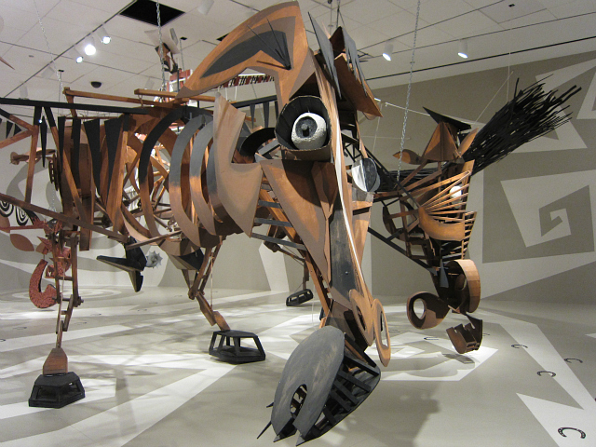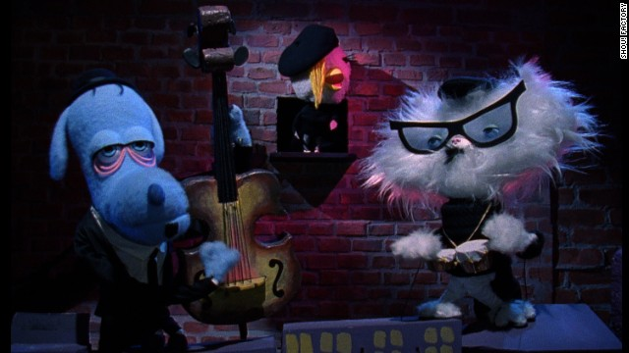
Lesson 4 – Creatures Come to Life
This culminating lesson will take 2-3 days. Students will take their creature to the next level and create a world for the creature to live. This world will be in the form of a comic. Students will create one or two pages of a graphic novel telling about a day in the life of their creature. Students may collaborate by using each other’s creatures in their stories, but each will write their own story. They will write an outline and draw a final coloured draft of their comic. Encounter with graphic novels by Art Spiegelman and favourite artists of students.
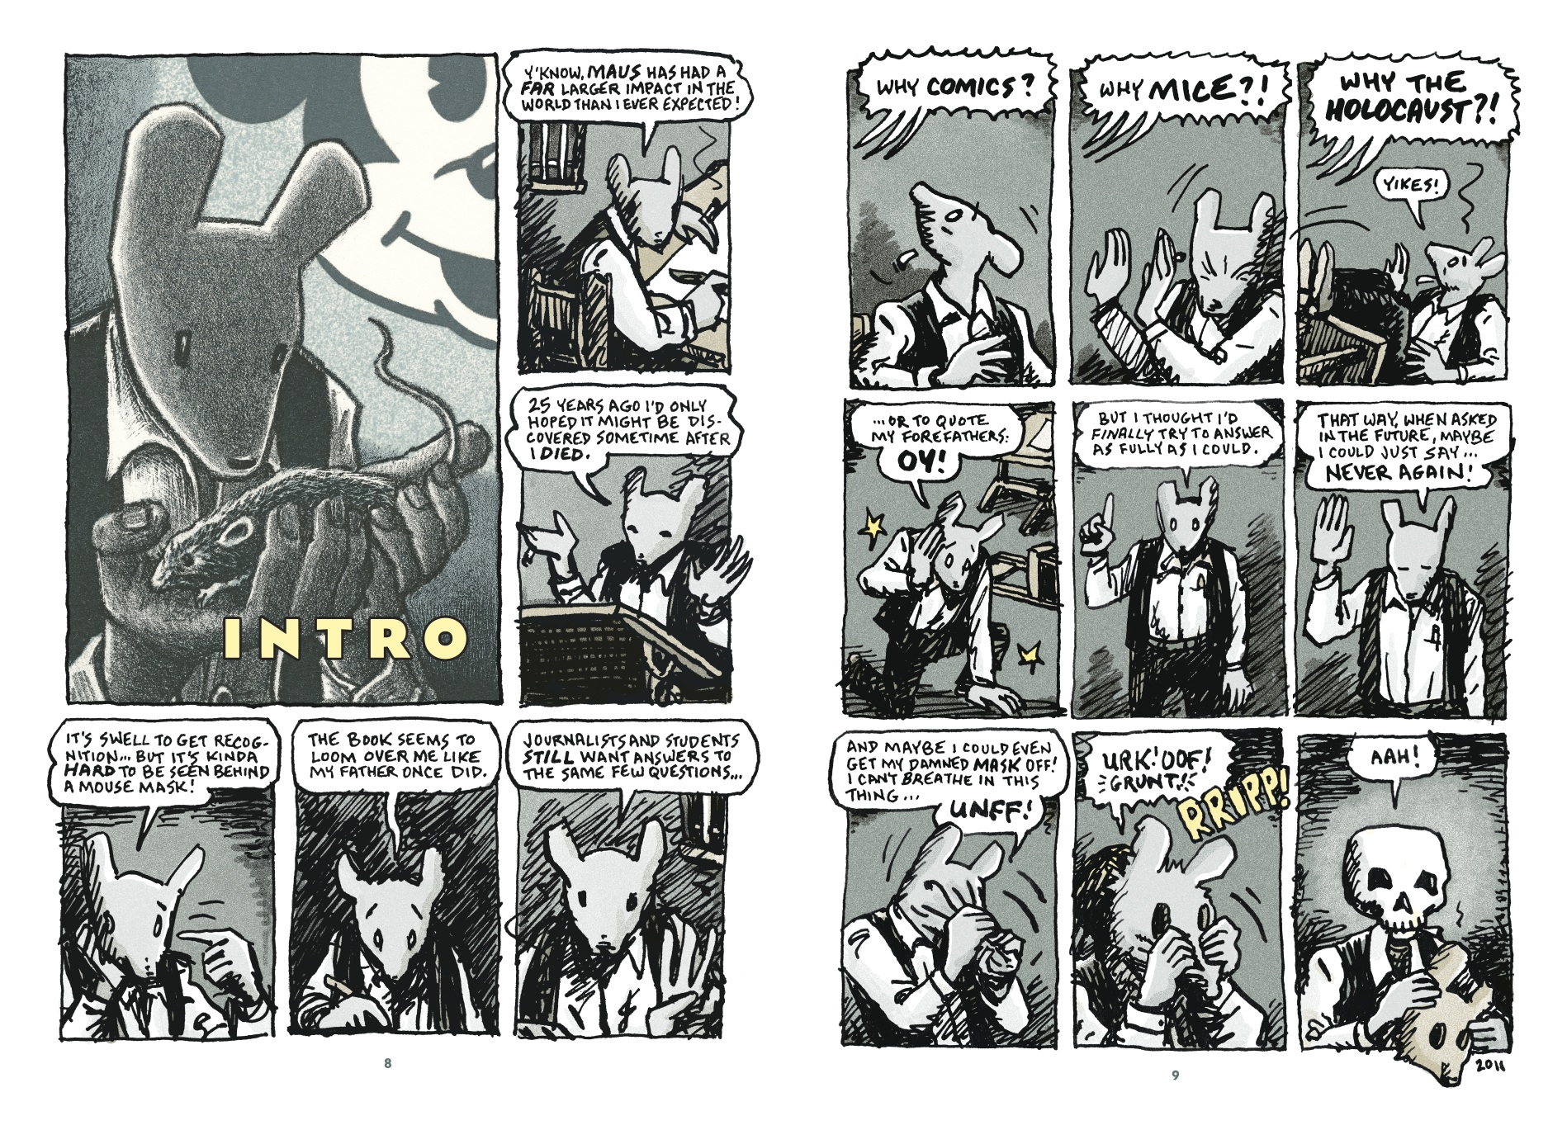

Lesson Title/Focus | Lesson 1 – Introduction to The Lost Thing | Date | September 7, 2015
Subject/Grade Level | Art and English Language Arts Grade 10 | Time Duration | 60 minutes
Unit | The Lost Thing by Shaun Tan | Teacher | Colleen Davies

ALBERTA PROGRAM OF STUDIES
General Learning Outcomes: |  |  | Specific Learning Outcomes:
ELA 10 GLOs  Students will listen, speak, read, write, view and represent:  1. to explore thoughts, ideas feelings and experiences.  2. to comprehend literature and other texts in oral, print , visual and multimedia forms and respond personally, critically and creatively.  4. to create oral, print visual and multimedia texts, and enhance the clarity and artistry of communication.  Art 10 GLO’s  Components 2 – Solve teacher directed problems of unity and emphasis in creating compositions.  Encounters – Compare the image content of certain periods |  |  | - Discover possibilities  - – Form tentative understandings  - –Experiment with language, image and structure  2.3 Respond to a variety of print and non-print texts. 2.3.3 – Appreciate the effectiveness and artistry of print and non-print texts  ART 10:  Encounters – Sources of Images  Investigate the process of abstracting form from a source in order to create objects or images.  Concepts  A. Artists simplify, exaggerate and rearrange parts of objects in their depictions of images. B. Artists select from natural forms in order to develop decorative motifs.
LEARNING OBJECTIVES (Students will) |  |  | ASSESSMENTS
- Listen to the book and view the video of The Lost Thing by Shaun Tan.  - Write a paragraph answering 5 questions about the book.  - Represent their ideas through newspaper and magazine collage |  |  | - Observations - observe student’s reactions and responses to book and video.  - Key Questions – What are the underlying messages of this book?  - What do you notice about the art? How does it make you feel?  - What do you think the author is saying about urbanization?  - What are the dominant colours in the book?  - Products & Performances - Worksheet of questions as they are listening to and watching The Lost Thing.  - Collage of a blending of the Industrial and Organic Worlds.
LEARNING RESOURCES CONSULTED |  |  | MATERIALS AND EQUIPMENT
- English Language Arts Program of Studies https://education.alberta.ca/media/645805/srhelapofs.pdf  - Art Program of Studies http://www.education.alberta.ca/media/313036/art10.pdf  - Tan, Shaun, Lost and Found, Lost and Found. Sydney: Arthur A. Levine Books, 2009. Print. |  |  | - Smartboard, Computer on which to show: https://www.youtube.com/watch?v=S1JoliFXH74  - A copy of the book Lost and Found by Shaun Tan  - Venn Diagram (28 copies)  - Cardstock Paper (28)  - Newspapers  - Magazines  - Scissors  - Glue Sticks
PROCEDURE
Introduction |  |  |  | Time
Attention Grabber |  | Imagine living in a world with very little colour, no plants, no flowers, no dirt, an industrial world. People hardly talk to each other, hardly ever smile; they just go to work and come home every day. Show the city picture with lines of people in the book. How would you feel? What would your life be like? |  | 5 minutes
Assessment of Prior Knowledge |  | How many of you have heard of the artist Shaun Tan? Who can tell me what Industrialism Art is?
Expectations for Learning and Behaviour |  | - Ready – pencils, paper, and cellphones away.  - Respectful – listening, responding,  - Responsible – working and allowing others to work.
Body |  |  |  | Time
Learning Activity #1 | Read The Lost Thing – have students take notes on Venn Diagrams while listening to the book. Explain: Label one side with The Boy’s World and one side with The Lost Thing’s World. Take notes accordingly and write similarities in the middle. |  |  | 10 minutes
Assessments/ Differentiation: | - Provide a more specific graphic organizer for students who need it.
Learning Activity #2 | Watch Video of The Lost Thing – have students continue to take notes on Venn Diagrams while listening to the book.  - Discuss the differences between the book and the film. |  |  | 23 minutes
Assessments/ Differentiation | - Provide a more specific graphic organizer for students who need it.
Learning Activity #3 | Create a Collage – provide students with materials listed above. - -Direct students to tear or cut newspaper and magazines into small pieces (no larger than 2 inches square, preferably 1-1.5 inches. – The purpose of the collage is to show the contrast between industrial and organic life. – Encourage Students to choose bright colours from the magazines and to arrange them in such in their own interpretation to portray how these two worlds can be inter mingled to build something interesting. |  |  | 22 minutes
Assessments/ Differentiation | - Encourage students with lower attention spans to use larger collage pieces to create their collage.
Extra Time Activity | Spend more time talking about impressions of the art of Shaun Tan. Show students his book The Red Tree and The Rabbits.
Closure |  |  |  | Time
Assessment of Learning: |  | Students will hand in their graphic organizers and their collages and receive a mark for these.
Feedback From Students: |  | Have students do a pair and share, talking about their favourite thing about The Lost Thing. Then have 2-3 pairs share with the class. |  | 5 minutes
Feedback To Students |  | Today we have just begun to look at this book, I think you will agree that there we will learn a lot.
Transition to Next Lesson |  | Next class we will focus on the creatures in the book. Ask students to begin bringing materials to build a creature with later in the week, suggest: cereal boxes, egg cartons, cans, yogurt containers, lids, foam pieces, fabric etc.

Lesson Title/Focus | Lesson 2 – Creating Creatures | Date | September 8, 2015
Subject/Grade Level | Art and English Language Arts Grade 10 | Time Duration | 60 minutes
Unit | The Lost Thing by Shaun Tan | Teacher | Colleen Davies

ALBERTA PROGRAM OF STUDIES
General Learning Outcomes: |  |  | Specific Learning Outcomes:
ELA 10 GLOs  Students will listen, speak, read, write, view and represent:  1. To explore thoughts, ideas feelings and experiences.  2. To comprehend literature and other texts in oral, print, visual and multimedia forms and respond personally, critically and creatively.  4. To create oral, print visual and multimedia texts, and enhance the clarity and artistry of communication.  Art 10 GLO’s  Components 2 – Solve teacher directed problems of unity and emphasis in creating compositions.  Encounters – Compare the image content of certain periods |  |  | - Discover possibilities  - – Form tentative understandings  - –Experiment with language, image and structure  2.3 Respond to a variety of print and non-print texts. 2.3.3 – Appreciate the effectiveness and artistry of print and non-print texts  ART 10:  Encounters – Sources of Images  Investigate the process of abstracting form from a source in order to create objects or images.  Concepts A. Artists simplify, exaggerate and rearrange parts of objects in their depictions of images. B. Artists select from natural forms in order to develop decorative motifs.  Drawings – Concept A. A change in drawing techniques can express a different point of view about the same subject matter.
LEARNING OBJECTIVES (Students will) |  |  | ASSESSMENTS
- Investigate the features of the creatures in the book The Lost Thing.  - Write a character sketch of their own creature  - Draw pictures of their creature from 5 different perspectives. |  |  | - Observations - observe student’s participation in discussion and work time.  - Key Questions – What do you notice about the creatures in the book?  - What will make up your creature? What are his/her weaknesses? What are his/her strengths?  - Products & Performances - Character sketch of their creature. - Drawings of their creatures from 5 perspectives.
LEARNING RESOURCES CONSULTED |  |  | MATERIALS AND EQUIPMENT
- English Language Arts Program of Studies https://education.alberta.ca/media/645805/srhelapofs.pdf  - Art Program of Studies http://www.education.alberta.ca/media/313036/art10.pdf  - Tan, Shaun, Lost and Found, Lost and Found. Sydney: Arthur A. Levine Books, 2009. Print.  - http://www.ngv.vic.gov.au/johnbrack/ - The art of John Brack  - http://www.hieronymus-bosch.org/ - The art of Hieronymus Bosch |  |  | - Computer and Smartboard Screen on which to show: Powerpoint with images of Bosch, Brack and Tan.  - Sketchbooks.  - Pencils  - Pencil Crayons
PROCEDURE
Introduction |  |  |  | Time
Attention Grabber |  | Show students images of art by Hieronymous Bosch and John Brack talk about their styles. Talk about the blending of unusual features. Show an image of the main creature from The Lost Thing and the picture of the lost things world with it’s many creatures. Ask students to describe what the creatures have in common. |  | 10 minutes
Assessment of Prior Knowledge |  | Do you think this is a new thing? Who has heard of a Centaur or a Pegasus? Wolverine? Other modern day creatures?
Expectations for Learning and Behaviour |  | - Ready – pencils, paper out, and cellphones away.  - Respectful – listening, responding,  - Responsible – working and allowing others to work.
Body |  |  |  | Time
Learning Activity #1 | Write a character sketch - What is your creature’s name, What are it’ strengths? What are its weaknesses? What can it teach you? What can you teach it? Why is it lost? Where did you find it? Is it happy? Sad? Lonely? |  |  | 20 minutes
Assessments/ Differentiation: | - Provide a worksheet with writing prompts for those who need it.
Learning Activity #2 | Draw a picture of your creature – encourage students to think of interesting or unusual perspectives. Have them draw their creature from at least 5 different perspectives. What colours will they use? Will they use shading to give it depth and shape? Keep in mind that you will be making 3D versions of this creature, so think about that as you are drawing it. What materials around your house could make up your creature? |  |  | 25 minutes
Assessments/ Differentiation | - Provide samples of sketches for those who need them to look at as they draw.
Extra Time Activity | Have students add more detail, or talk to each other about their creatures.
Closure |  |  |  | Time
Assessment of Learning: |  | Students will hand in their character sketches and drawings and receive a mark for these.
Feedback From Students: |  | - Can you name some of the drawing techniques used?  - Why did you choose the colours that you chose?  - What was your inspiration for your drawing?  - What strengths do you see in your drawing?  - What weaknesses do you see?  - How would you change it? |  | 5 minutes
Feedback To Students |  | So far we have looked at the worlds of The Lost Thing and the creatures. You have learned about some interesting artists.
Transition to Next Lesson |  | Next class you will build 3D versions of your creatures. Everyone needs to bring materials to build – cereal boxes, egg cartons, cans, yogurt containers, lids etc.

Lesson Title/Focus | Lesson 3 & 4 – Creating 3D Creatures | Date | September 9-10, 2015
Subject/Grade Level | Art and English Language Arts Grade 10 | Time Duration | 60 minutes
Unit | The Lost Thing by Shaun Tan | Teacher | Colleen Davies

ALBERTA PROGRAM OF STUDIES
General Learning Outcomes: |  |  | Specific Learning Outcomes:
ELA 10 GLOs  Students will listen, speak, read, write, view and represent:  1. To explore thoughts, ideas feelings and experiences.  2. To comprehend literature and other texts in oral, print, visual and multimedia forms and respond personally, critically and creatively.  4. To create oral, print visual and multimedia texts, and enhance the clarity and artistry of communication.  Art 10 GLO’s  Components 2 – Solve teacher directed problems of unity and emphasis in creating compositions.  Encounters – Compare the image content of certain periods |  |  | - Discover possibilities  - – Form tentative understandings  - –Experiment with language, image and structure  2.3 Respond to a variety of print and non-print texts. 2.3.3 – Appreciate the effectiveness and artistry of print and non-print texts  ART 10:  Encounters – Sources of Images  Investigate the process of abstracting form from a source in order to create objects or images.  Compositions – Component 1 Extend their knowledge of and familiarity with the elements and principles of design through practise in composing two and three-dimensional images.
LEARNING OBJECTIVES (Students will) |  |  | ASSESSMENTS
- Draw a plan of how you will build your 3-D Creatures  - Create a sculpture with gathered materials.  - Write a critique of one fellow student’s sculpture. |  |  | - Observations - observe student’s participation in discussion and work time.  - Key Questions – What did you notice about the sculptures of Wayne White?  - What types of materials did he use?  - Products & Performances - sketches and plans for sculpture  - sculpture made with found materials
LEARNING RESOURCES CONSULTED |  |  | MATERIALS AND EQUIPMENT
- English Language Arts Program of Studies https://education.alberta.ca/media/645805/srhelapofs.pdf  - Art Program of Studies http://www.education.alberta.ca/media/313036/art10.pdf  - Tan, Shaun, Lost and Found, Lost and Found. Sydney: Arthur A. Levine Books, 2009. Print.  - Beauty is Embarrassing Trailer https://www.youtube.com/watch?v=PHQ3dTRM6xM |  |  | - Computer and Smartboard Screen on which to show: Video of Beauty is Embarrassing (Trailer)  - Sketchbooks.  - Pencils  - Cereal Boxes, containers, cans, pieces of cardboard, foam, etc.  - Packing tape, duct tape, wire, pipe cleaners  - Scissors, glue
PROCEDURE
Introduction |  |  |  | Time
Attention Grabber |  | Show students the trailer of the video Beauty is Embarrassing a documentary about Wayne White. Talk about the how |  | 10 minutes
Assessment of Prior Knowledge |  | Have any of you ever made a sculpture? What do you think of when you think of sculpture?
Expectations for Learning and Behaviour |  | - Ready – pencils, paper out, and cellphones away.  - Respectful – listening, responding,  - Responsible – working and allowing others to work.
Body |  |  |  | Time
Learning Activity #1 | Make a plan of how you will represent your creature 3 – dimensionally.  Gather the materials that you will need.  Use the sketches that you made last class.  What modifications will you have to make? |  |  | 10 minutes
Assessments/ Differentiation: | - Observe students as they are working; encourage them by displaying pictures of found sculptures on the Smartboard.
Learning Activity #2 | - Build your creatures with the materials available.  - Use tape, wire, pipe cleaners or what ever you need to put it together.  - Take photos of it and post to class website.  - Work together with other students as necessary to help each other bring your creatures to life. |  |  | 40minutes
Assessments/ Differentiation | - Observe students as they are working and provide guidance for those who are struggling  - Ask questions to help them solve problems they might be having with their sculptures
Extra Time Activity | Have students add more detail, or talk to each other about their creatures.
Closure |  |  |  | Time
Assessment of Learning: |  | Students will store their sculptures in the art room and continue work on them over two days. They will write their own critiques and also be given a mark from the teacher based upon the product and the critique.
Feedback From Students: |  | - How is your 3-D Creature different from your drawing?  - What were some of the challenges of creating a 3-D version of your drawing?  - Why did you choose the materials that you chose?  - How did you overcome those challenges?  - What do you like about your sculpture?  - What would you like to change? |  | 5 minutes
Feedback To Students |  | - You have created some interesting sculptures.  - You have used some very creative ways of connecting your materials.  - You have made some very interesting material choices.
Transition to Next Lesson |  | Next class you will be bringing your creatures to life in a different way, as we will write a story about your creature and put it into a comic. Your homework is to bring one of your favourite graphic novels to next class and be prepared to share it with a partner.

Lesson Title/Focus | Lesson 5 & 6 Creatures Come to Life | Date | September 11-14, 2015
Subject/Grade Level | Art and English Language Arts Grade 10 | Time Duration | 60 minutes
Unit | The Lost Thing by Shaun Tan | Teacher | Colleen Davies

ALBERTA PROGRAM OF STUDIES
General Learning Outcomes: |  |  | Specific Learning Outcomes:
ELA 10 GLOs  Students will listen, speak, read, write, view and represent:  1. To explore thoughts, ideas feelings and experiences.  2. To comprehend literature and other texts in oral, print, visual and multimedia forms and respond personally, critically and creatively.  4. To create oral, print visual and multimedia texts, and enhance the clarity and artistry of communication.  Art 10 GLO’s  Components 2 – Solve teacher directed problems of unity and emphasis in creating compositions.  Encounters – Compare the image content of certain periods |  |  | - Discover possibilities  - –Experiment with language, image and structure  2.3 Respond to a variety of print and non-print texts. 2.3.3 – Appreciate the effectiveness and artistry of print and non-print texts  4.1 Develop and present a variety of print and nonprint texts  4.1.3 – Develop content  4.1.4 – Use production, publication and presentation strategies and technologies consistent with context  ART 10:  Encounters – Sources of Images  Investigate the process of abstracting form from a source in order to create objects or images.  Concepts A - Movement, rhythm and direction are used in recording humans and their activities
LEARNING OBJECTIVES (Students will) |  |  | ASSESSMENTS
- Observations - observe student’s participation in discussion and work time.
- Key Questions – What do you notice about some of your favourite graphic novels?
- Products & Performances - a hand drawn comic about a day in the life of their creature.
LEARNING RESOURCES CONSULTED |  |  | MATERIALS AND EQUIPMENT
- English Language Arts Program of Studies https://education.alberta.ca/media/645805/srhelapofs.pdf  - Art Program of Studies http://www.education.alberta.ca/media/313036/art10.pdf  - Tan, Shaun, Lost and Found, Lost and Found. Sydney: Arthur A. Levine Books, 2009. Print.  - Art Spiegelman’s MetaMaus http://www.randomhouse.com/kdpg/graphicnovels/metamaus/ |  |  | - Laptops for students to use.  - Pencils  - Pencil Crayons  - Storyboard templates (28)  - Copy of rubric with area for reflection (28)
PROCEDURE
Introduction |  |  |  | Time
Attention Grabber |  | Have students share their favourite graphic novel with a partner. Have them decide what makes a graphic novel good. One person from each pair will share that idea with the class. Show them some images of Art Spiegelman’s works and discuss the qualities of his drawings. Review images from The Lost Thing and remind students of the way Shaun Tan mixes the organic and the industrial. Encourage them to keep those things in mind as they move on. |  | 10 minutes
Assessment of Prior Knowledge |  | Who has ever created a comic strip? Who has ever written a story?
Expectations for Learning and Behaviour |  | - Ready – pencils, paper out, and cellphones away.  - Respectful – listening, responding,  - Responsible – working and allowing others to work.
Body |  |  |  | Time
Learning Activity #1 | Build on your character sketch – What does your creature like to do? What would a day in the life of your creature look like? What kind of friends might your creature have? What would his house look like? Does he have a job? Remind students to think  - Write a rough draft of your story – encourage collaboration during this phase in the sharing of ideas and character, however each student must write and draw their own story.  - Use the storyboard template to create your sketches and dialogue.  - Use more than one template if necessary. |  |  | 20 minutes
Assessments/ Differentiation: | - Provide a worksheet with writing prompts for those who need it.
Learning Activity #2 | - Add more details and colours to your storyboard.  - Make a cover page for your story.  - Publish the final draft of your work.  - Write a critique of your work. |  |  | 25 minutes
Assessments/ Differentiation | - Provide samples of sketches for those who need them to look at as they draw.
Extra Time Activity | Spend more time critiquing fellow students comics.
Closure |  |  |  | Time
Assessment of Learning: |  | Student’s comics will be marked using the rubric attached.
Feedback From Students: |  | - What are the dominant colours of your comic?  - Is there an artist that has influenced you in the choices of colour and design of your storyboard?  - Have you combined organic and inorganic elements into your composition?  - What do you like about your drawings?  - Have you been able to show action in your drawings?  - How much detail did you put into the backgrounds of your frames?  - Does the dialogue fit with the drawing? |  | 5 minutes
Feedback To Students |  | - It has been exciting to see the progress of your creations throughout this unit.  - By looking at the strengths and weaknesses of your works you have been able to refine your drawings.  - You have created unique characters and stories.
Transition to Next Lesson |  | We will take photos of your comics and put them on our class website. Students may then write critiques in the comment boxes.

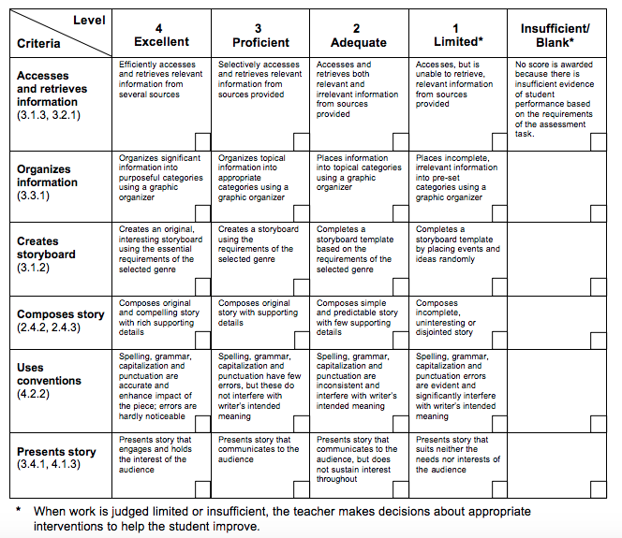
What did I learn from this experience? What were the strengths of my work? What were the weaknesses? What would I do differently in the future? What influenced my choices?
